(Approx. 1045 words)

Recycling a PC
By Dick Maybach, Brookdale Computer User Group
www.bcug.com
n2nd (at) att.net
There are two issues to address when you decide to discard an old PC (1) finding somebody who wants it and (2) removing your data from it. The first is more difficult for older units, but not impossible; our local Goodwill was delighted to get an XP-era desktop with a keyboard and mouse but no display. I had replaced Windows XP with a current version of Linux to make it Internet-safe. I wouldn’t have been comfortable donating a machine with an operating system that couldn’t be kept current.

Your first step in selling a PC or giving it to a charity or a friend is to figure out what it is. For Windows 10, type “settings” in the search window, then go to Settings, to System, and finally to About to see the window is shown in Figure 1. (For the remainder of this article, I’ll shorten such commands to “settings” > Settings > System > About.)

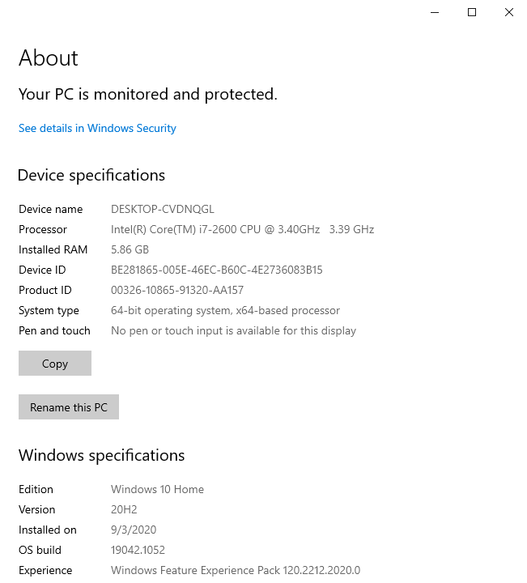

Figure 1. Windows 10 Device Specifications Screen.

Similar procedures work for other versions of Windows, see https://www.tenforums.com/tutorials/132836-check-what-processor-cpu-windows-pc.html. A key item here is whether the hardware is 32 or 64 bit. Although Microsoft still supports 32-bit processors, they are obsolete, and most Linux versions require 64-bit processors. Another key item is the version of Windows. You do nobody a favor by giving them a PC with an obsolete operating system, as it isn’t safe to use on the Internet. The traditional remedy is to replace the OS with Linux, but it may take some searching to find one for a 32-bit CPU.

An alternative to the Windows tool is a live USB drive such as PartedMagic, available at https://partedmagic.com/ for $13, Figure 2. Unfortunately, you must be careful, as it’s sold only as a subscription, and if you don’t cancel it within three months, your credit card will be billed another $13. I’m disappointed that the supplier has decided to take this approach. If you choose to go ahead, be sure to download both the current version (which runs only on 64-bit machines) and the old one, pmagic_2020_05_20.iso (which runs on 32-bit machines and all the 64-bit ones I’ve tried). Figure 2 is a screenshot of the latter.

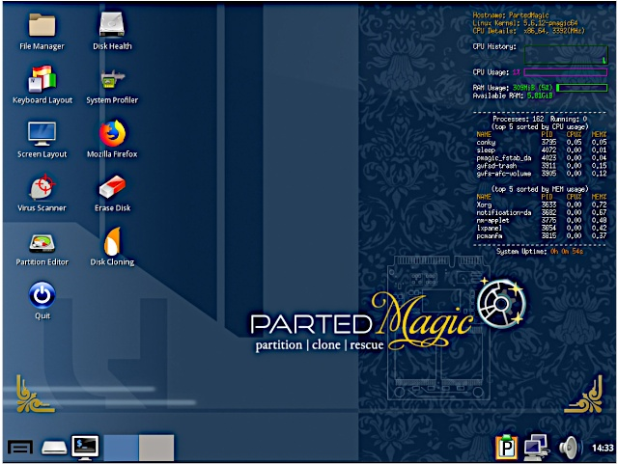

Figure 2. PartedMagic Home Screen.

The information you need appears in the third line of text in the top right corner of the desktop, “CPU Details: x86_64, 3392 MHz” here. You can see more details by selecting the System Profiler icon on the desktop or bottom left icon, then System Information and exploring the Hardware Lister.

Is your PC worth recycling? A 64-bit one certainly is, and a 32-bit one maybe, if it isn’t too old. One with Windows XP, a cathode-ray-tube display, and legacy accessory ports (PS-2 for its keyboard and mouse and VGA for display) is probably ready for the landfill, but do check with a local charity. With a solid-state display and USB ports, a more modern one is more likely to be usable. Windows 10 supports 32-bit machines for now, although there are signs that this may end. You can still find a few Linux distributions that do, https://www.makeuseof.com/linux-distros-with-32-bit-support/, even though most require 64 bits.

You should remove all your data before selling your old PC, giving it away, or disposing of it. Deleting files isn’t enough, as these are easily recovered. They must be wiped; that is, over-written with unrelated data. This is especially convenient with recent versions of Windows, https://www.pcmag.com/how-to/how-to-wipe-your-hard-drive. For Windows 10, type “settings” > Settings> Update & Security > Recovery > Get started (under Reset this PC) to see Figure 3.

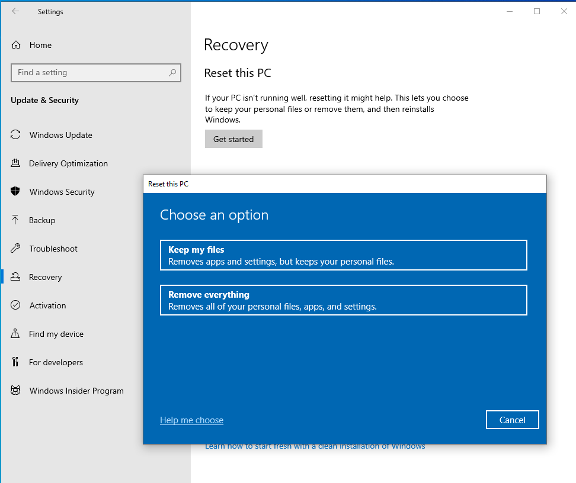

Figure 3. Windows 10 Reset Screen.

The “Remove everything” option will sanitize your PC but leave Windows 10 installed. Although similar options are available in older Windows versions, they are less useful since these are no longer supported. In such cases, my choice would be to wipe the disk of everything and install Linux, which results in an operable PC. But, of course, the operating system is immaterial for those who want to surf the Internet and exchange e-mail.

Disk wiping utilities are common, and one is included in PartedMagic, mentioned above. First, select Disk Cleaning on PartedMagic’s home screen as shown in Figure 2, then select the Block Wiping tab to see Figure 43. (The options under the Secure Erase tab use utilities included on many hard disks.) I prefer Nwipe, a clone of DBAN, https://tiptopsecurity.com/how-to-securely-wipe-your-hard-drive-with-dban-erase-your-data-for-good/ and available separately.

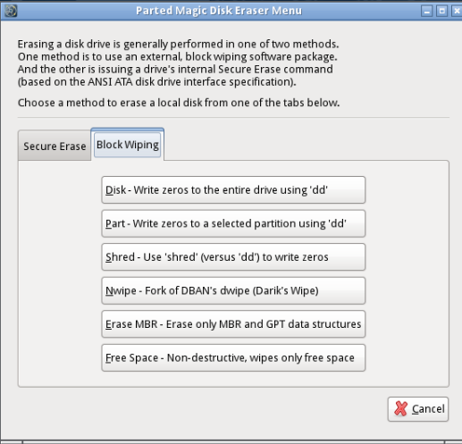

Figure 4. PartedMagic Disk Eraser Windows.

The wipe process will probably take several hours, but it takes no supervision, so you can start it and walk away. If the process fails, the safe remedy is to remove the disk and physically destroy it by taking it to the curb and using a hammer. Do this even if your machine is headed for a landfill. You may be tempted to omit it, thinking you have nothing to hide. However, if you’ve ever used the PC to access the Internet, it has your browsing history, with the sites you’ve visited and perhaps their passwords, if you’ve used it for e-mail, it has your messages, and if you’ve used it to prepare your taxes, it has your old returns. How would you feel if such data were displayed on a website? By the way, that your PC isn’t operable doesn’t mean its disk can’t be read. In this case, the only safe option is to remove the disk, give it the hammer treatment, and discard the PC separately.

Even though it requires some effort, PC recycling is worthwhile. One that you consider too old and slow to be useful can be valuable to a person or organization that doesn’t have one.

Modern cell phones also contain sensitive data, which should be deleted before being discarded or traded in. Follow this procedure for Android phones. Start the Settings app, then System > Advanced > Reset Options > Erase all data (factory reset) and follow the instructions. You will have to answer several “Are you sure?” questions, and the process will take several minutes. This isn’t long enough for a secure delete process, and I suspect that a determined hacker could recover the data, but at least it’s protected from casual ones.

